How to search for and request Interlibrary Loan books


Step 1
Click on the “Search and request” menu.

Step 2
Enter your search terms in the simple, Google-like search bar at the top of the screen, and click “Search”.

Step 3

The search will begin, and your page will start updating. Wait for the “Searching...” progress bar in the upper left to complete (it's very fast!).
Your search results will look like this:
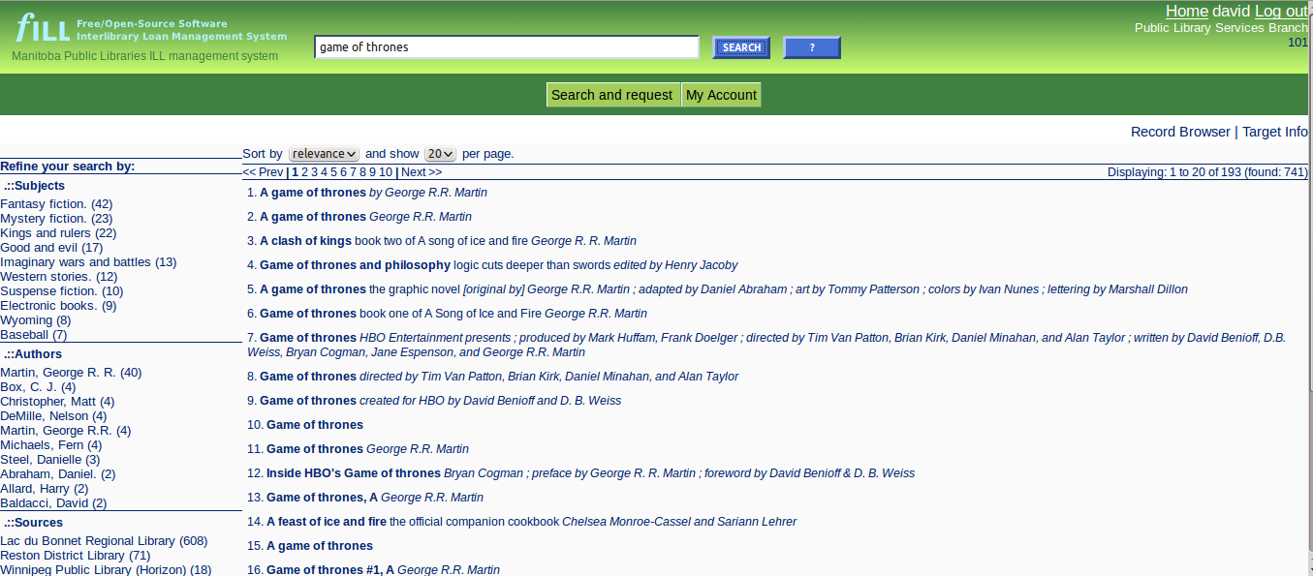

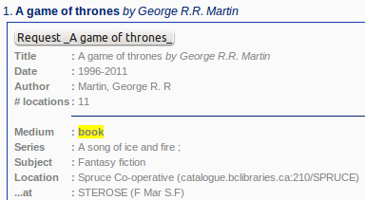
Step 4
Click on the title you are interested in.
If this is the book you'd like to request, click on the “Request” button.
(The “Request” button show the title, too. In this case, “Request _A game of thrones_”)
If this isn't the right book, click on the title again to hide the details, and try another title.

You're done!
You'll see a new window or browser tab which confirms that your request has been placed.

Close this window or browser tab to return to your search results.
Your librarian will try to get the book for you, and let you know when it comes in. (You should usually hear from the library in about a week.)

Becoming a Power-user!

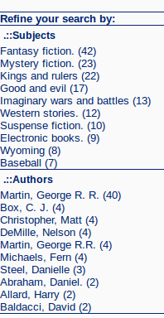
Refining your search
In your search results page, along the left-hand side, there is a list of all of the subjects and authors that were found in all of the records your search returned.
The number in parenthesis counts how many of your results have that particular subject or author.
Clicking on a subject or author will refine your search terms by adding that specific information. The system will re-do the search with your new terms.
You can continue to refine your results as often as you need.
Or you can enter a completely new search into the search bar at the top of the screen.

Sorting the results, and moving from page to page

Search results are sorted by relevance by default. This should place the books that most closely match your search terms at the top of the list.
You can choose to sort by title or by publication date, by clicking the “Sort by” button at the top of the results list.
You can page through your results by clicking on the “<< Prev” and “Next >>” links, or by choosing a page number to jump to.

